John Michael Go
Career Entry Level Java Programming
Date: Jan. 16, 2013

DAY 4

Program Name: Loop2

Objective: Program that produces even number.

Algorithm:

- Program will display even numbers between 10 and 101.

Flowchart:

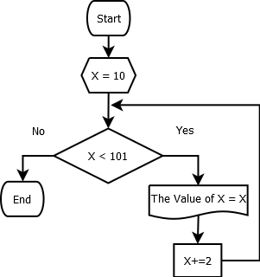

Pseudocode:

public class Loop2 {

public static void main(String[] args) {

for (int x = 10; x < 101; x+=2 ){
System.out.println("The value of x = " +x);

}

}

}

Screenshot:

